**GLOBAL YOUTUBE STATISTICS DATASET**

* **Sharon Blessy J V**

1. **What are the top 10 YouTube channels based on the number of subscribers?**

**Ans.**

Code Snippet Used:

subs_sorted = yt.sort_values(by='subscribers', ascending=False)

top_10 = subs_sorted.head(10)

print(top_10[['rank','Youtuber','subscribers','Title']])

Output:

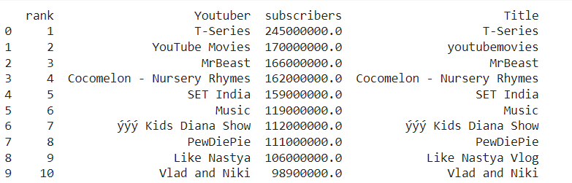

1. **Which category has the highest average number of subscribers?**

**Ans.**

Shows have the highest average number of subscribers. Below given is the code snippet used to find the same.

yt_1 = yt[yt['subscribers'] != 0]

avgsubs_by_category = yt_1.groupby('category')['subscribers'].mean().sort_values(ascending=False)

print(avgsubs_by_category)

print("Category with the highest average number of subscribers : " + avgsubs_by_category.index[0])

1. **How many videos, on average, are uploaded by YouTube channels in each category?**

**Ans.**

**Code Snippet Used:**

yt_1 = yt[yt['subscribers'] != 0]

avgvid_by_category = yt_1.groupby('category')['uploads'].mean().round().astype(int)

print(avgvid_by_category)

**Output:**

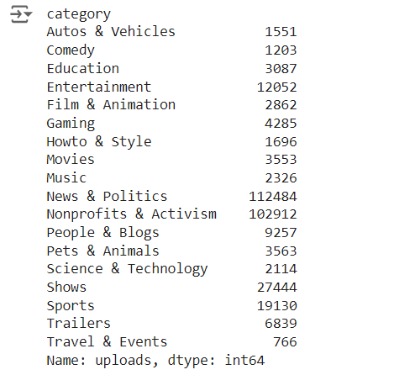

1. **What are the top 5 countries with the highest number of YouTube channels?**

**Ans.**

Top 5 countries include the United States, India, Brazil, United Kingdom and Mexico.

**Code Snippet:**

**top_5 = yt.groupby('Country')['Youtuber'].count().sort_values(ascending=False).head(5)**

**print(top_5)**

**Output:**

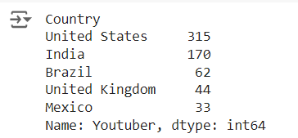

1. **What is the distribution of channel types across different categories?**

**Ans.**

**Code Snippet:**

**distribution = yt.groupby(['category', 'channel_type']).size().unstack(fill_value=0)**

**distribution.plot(kind='bar', stacked=True)**

**plt.title('Distribution of Channel Types Across Categories')**

**plt.xlabel('Category')**

**plt.ylabel('Count')**

**plt.show()**

**Output:**

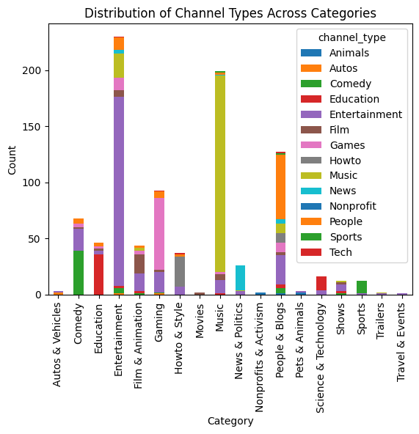

1. **Is there a correlation between the number of subscribers and total video views for YouTube channels?**

**Ans.**

**Code Snippet:**

**sub_view_corr = yt['subscribers'].corr(yt['video views'])**

**print(sub_view_corr)**

**Output:**



It indicates a strong positive relationship between no. of subscribers and total video views for the Youtube Channels.

1. **How do the monthly earnings vary throughout different categories?**

**Ans.**

**Code Snippet:**

**monthly_earnings_dist = yt.groupby('category')['highest_monthly_earnings'].mean().sort_values(ascending=False)**

**sns.barplot(x=monthly_earnings_dist.index, y=monthly_earnings_dist.values, palette='viridis')**

**plt.title('Average Monthly Earnings by Category')**

**plt.xlabel('Category')**

**plt.ylabel('Average Monthly Earnings')**

**plt.xticks(rotation=90)**

**plt.show()**

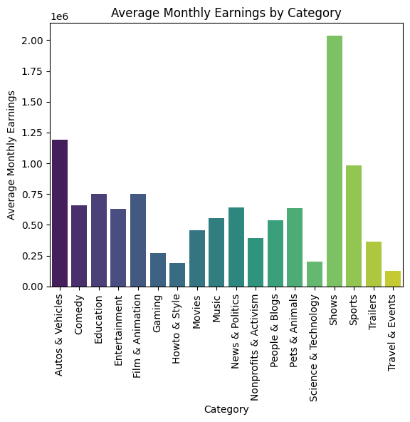

1. **What is the overall trend in subscribers gained in the last 30 days across all channels?**

**Ans.**

**Code Snippet Used:**

**mean_sub_gain = yt['subscribers_for_last_30_days'].mean()**

**highest = yt['subscribers_for_last_30_days'].max()**

**ch_highest = yt[yt['subscribers_for_last_30_days'] == highest]['Title'].values**

**lowest = yt['subscribers_for_last_30_days'].min()**

**ch_lowest = yt[yt['subscribers_for_last_30_days'] == lowest]['Title'].values**

**print(f"Average Subscribers Gained: {mean_sub_gain}")**

**print(f"Highest Subscribers Gained: {highest}")**

**print("Channels with highest subscribers Gained: ",*ch_highest)**

**print(f"Lowest Subscribers Gained: {lowest}")**

**print("Channels with least subscribers Gained:")**

**print(*ch_lowest[0:8], sep = ", ")**

**print(*ch_lowest[8:len(ch_lowest)], sep = ", ")**

**Output:**

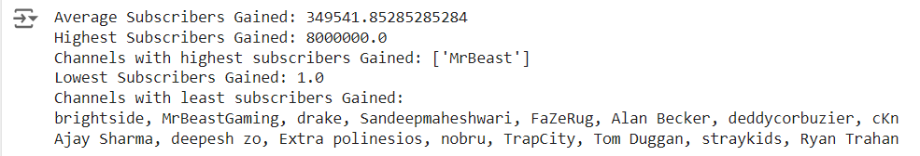

1. **Are there any outliers in terms of yearly earnings from YouTube channels?**

**Ans.**

**Code Snippet:**

**print(yt.isnull().sum()[['lowest_monthly_earnings','highest_monthly_earnings']])**

**print(yt.describe()[['lowest_monthly_earnings','highest_monthly_earnings']])**

**Output:**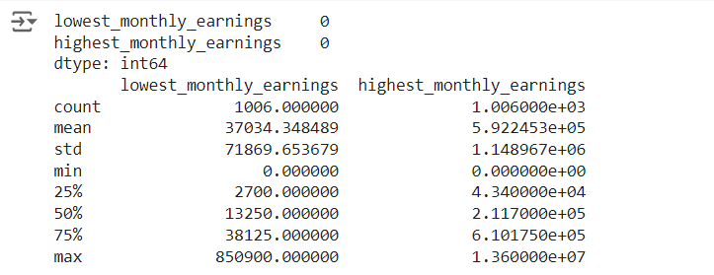

Some channels have monthly earnings of 0 .

1. **What is the distribution of channel creation dates? Is there any trend over time?**

**Ans.**

**Code Snippet:**

**yt['created_year'] = pd.to_datetime(yt['created_year'], format='%Y')**

**time_trend = yt.groupby('created_year')['Youtuber'].count()**

**plt.figure(figsize=(10, 6))**

**plt.plot(time_trend.index, time_trend.values)**

**plt.title('Distribution of Channel Creation Dates')**

**plt.xlabel('Year')**

**plt.ylabel('Number of Channels Created')**

**plt.show()**

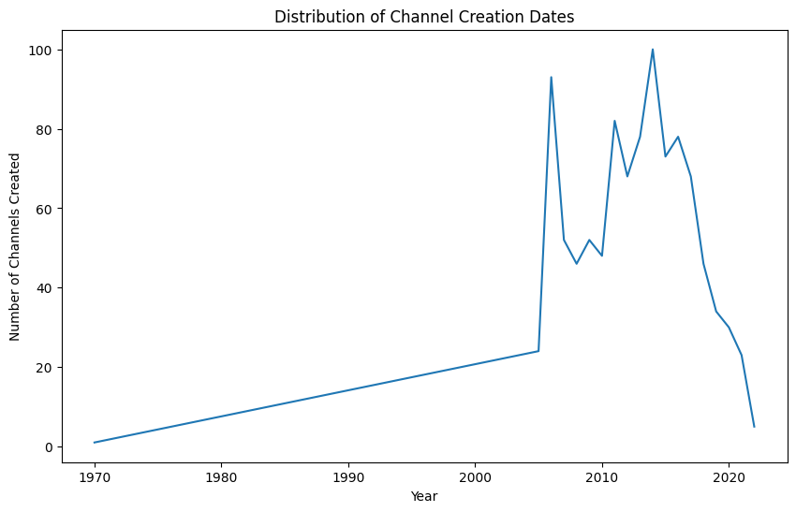

1. **Is there a relationship between gross tertiary education enrollment and the number of YouTube channels in a country?**

**Ans.**

**Code Snippet:**

**countries = yt['Country'].unique()**

**countries = [country for country in countries if pd.notna(country)]**

**countries.sort()**

**channel_count_by_country = yt.groupby('Country')['Youtuber'].count()**

**gross_edu_by_country = yt.groupby('Country')['Gross tertiary education enrollment (%)'].mean()**

**plt.bar(countries, gross_edu_by_country)**

**plt.title('Gross Tertiary Education Enrollment by Country')**

**plt.xlabel('Country')**

**plt.ylabel('Gross Tertiary Education Enrollment (%)')**

**plt.xticks(rotation=90)**

**plt.show()**

**plt.bar(countries, channel_count_by_country)**

**plt.title('Number of YouTube Channels by Country')**

**plt.xlabel('Country')**

**plt.ylabel('Number of Channels')**

**plt.xticks(rotation=90)**

**plt.show()**

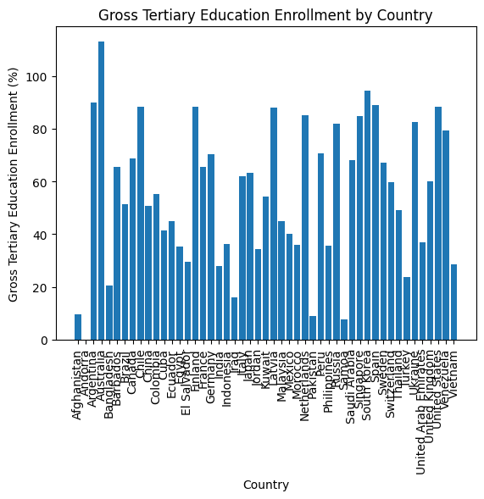

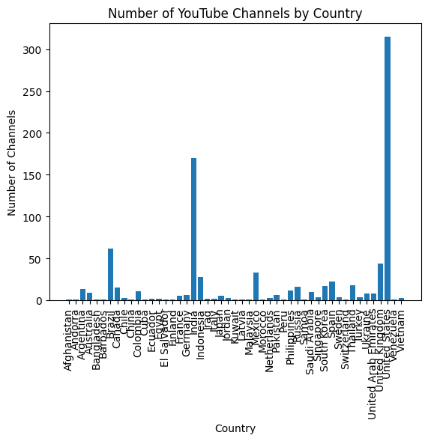

There is no visible relationship that can be observed.

1. **How does the unemployment rate vary among the top 10 countries with the highest number of YouTube channels?**

**Ans.**

**Code Snippet:**

**top_10_countries = yt.groupby('Country')['Youtuber'].count().sort_values(ascending=False).head(10).index**

**top_10_data = yt[yt['Country'].isin(top_10_countries)]**

**unemployment_rate_by_country = top_10_data.groupby('Country')['Unemployment rate'].mean()**

**plt.bar(unemployment_rate_by_country.index, unemployment_rate_by_country.values)**

**plt.title('Unemployment Rate in Top 10 Countries with Highest YouTube Channels')**

**plt.xlabel('Country')**

**plt.ylabel('Unemployment Rate (%)')**

**plt.xticks(rotation=45)**

**plt.show()**

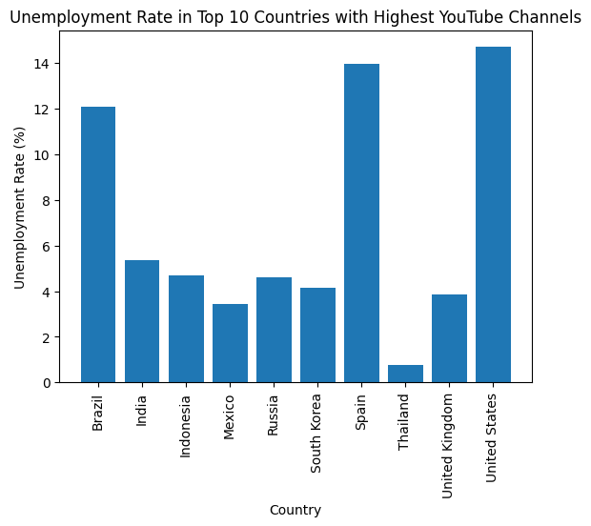

1. **What is the average urban population percentage in countries with YouTube channels?**

**Ans.**

**Code Snippet:**

**avg_urban_population_by_country = yt.groupby('Country')['Urban_population'].mean().dropna()**

**print(avg_urban_population_by_country)**

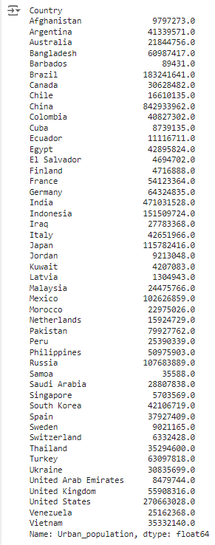

1. **Are there any patterns in the distribution of YouTube channels based on latitude and longitude coordinates?**

**Ans.**

**Code Snippet:**

**from mpl_toolkits.basemap import Basemap**

**latitudes = yt['Latitude'].dropna()**

**longitudes = yt['Longitude'].dropna()**

**plt.figure(figsize=(10, 7))**

**m = Basemap(projection='merc', llcrnrlat=-60, urcrnrlat=80, llcrnrlon=-180, urcrnrlon=180, resolution='c')**

**m.drawcoastlines()**

**m.drawcountries()**

**x, y = m(longitudes.values, latitudes.values)**

**m.scatter(x, y, marker='o', color='red', s=10, alpha=0.5)**

**plt.title('Geographic Distribution of YouTube Channels')**

**plt.show()**

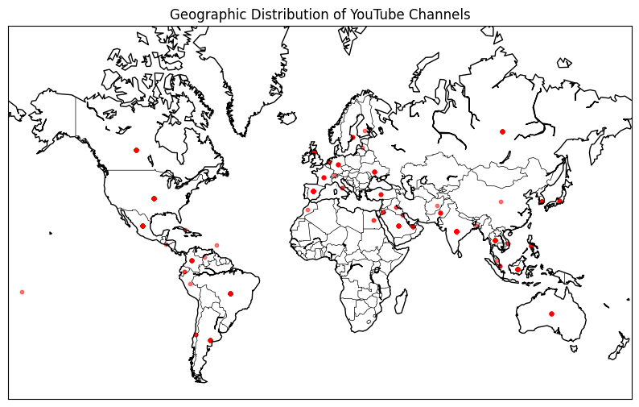

1. **What is the correlation between the number of subscribers and the population of a country?**

**Ans.**

**Code Snippet:**

**correlation = yt['subscribers'].corr(yt['Population'])**

**print("Correlation between no. of subscribers and the population : ",correlation)**



1. **How do the top 10 countries with the highest number of YouTube channels compare in terms of their total population?**

**Ans.**

**Code Snippet:**

**top_10_countries = yt.groupby('Country')['Youtuber'].count().sort_values(ascending=False).head(10).index**

**top_10_data = yt[yt['Country'].isin(top_10_countries)]**

**population_by_country = top_10_data.groupby('Country')['Population'].mean().sort_values(ascending=False)**

**plt.figure(figsize=(10, 6))**

**plt.bar(population_by_country.index, population_by_country.values)**

**plt.title('Total Population of Top 10 Countries with Highest YouTube Channels')**

**plt.xlabel('Country')**

**plt.ylabel('Total Population')**

**plt.xticks(rotation=90)**

**plt.show()**

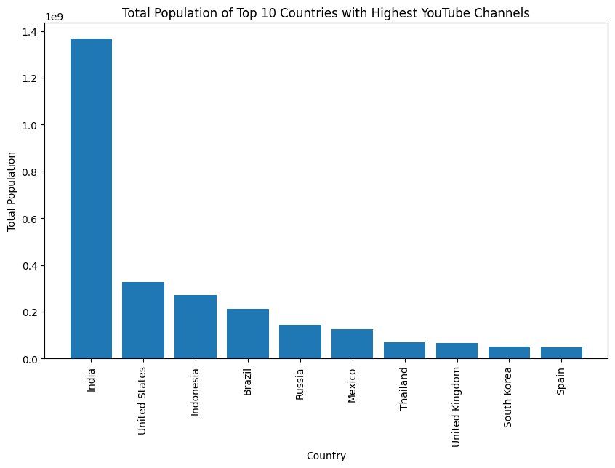

1. **Is there a correlation between the number of subscribers gained in the last 30 days and the unemployment rate in a country?**

**Ans.**

**Code Snippet:**

**correlation = yt['subscribers_for_last_30_days'].corr(yt['Unemployment rate'])**

**print("Correlation between subscribers gained in the last 30 days and unemployment rate:", correlation)**

**Output:**

This indicates a very weak negative relationship.

1. **How does the distribution of video views for the last 30 days vary across different channel types?**

**Ans.**

**Code Snippet:**

**plt.figure(figsize=(10, 6))**

**sns.barplot(x='channel_type', y='video_views_for_the_last_30_days', data=yt)**

**plt.xticks(rotation=90)**

**plt.title('Distribution of Video Views for the Last 30 Days by Channel Type')**

**plt.xlabel('Channel Type')**

**plt.ylabel('Video Views in the Last 30 Days')**

**plt.tight_layout()**

**plt.show()**

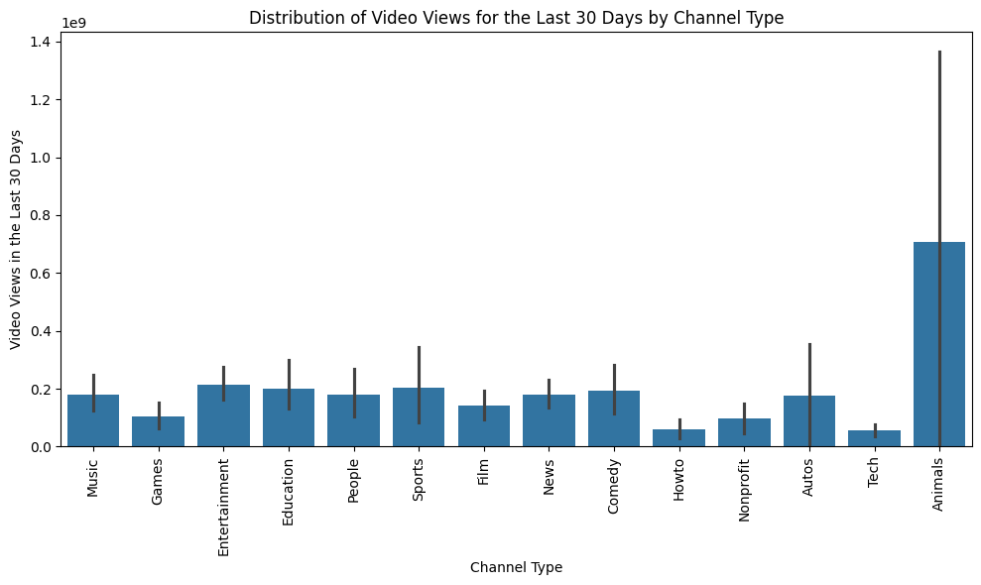

1. **Are there any seasonal trends in the number of videos uploaded by YouTube channels?**

**Ans.**

**Code Snippet:**

**upload_trend = yt.groupby(yt['created_month'])['uploads'].sum()**

**sns.barplot(x=upload_trend.index, y=upload_trend.values, palette='viridis')**

**plt.title('Upload Trend by Month')**

**plt.xlabel('Month')**

**plt.ylabel('Number of Videos Uploaded')**

**plt.show()**

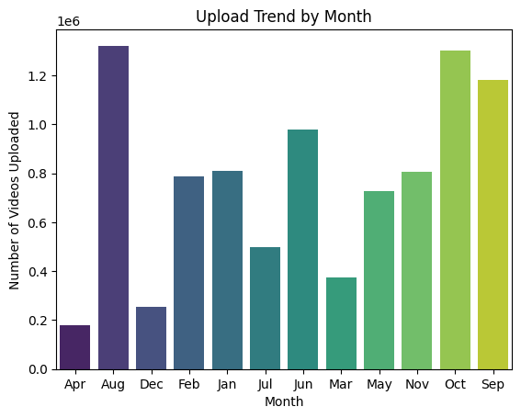

1. **What is the average number of subscribers gained per month since the creation of YouTube channels till now?**

**Ans.**

**Code Snippet:**

**avg_subscribers_gained_per_month = yt.groupby(yt['created_month'])['subscribers_for_last_30_days'].mean()**

**sns.barplot(x=avg_subscribers_gained_per_month.index, y=avg_subscribers_gained_per_month.values, palette='plasma')**

**plt.title('Upload Trend by Month')**

**plt.xlabel('Month')**

**plt.ylabel('Number of subscribers gained per month')**

**plt.show()**

